Automated Instance Management Using AWS Lambda and Boto3
STEP 1: Created 2 EC2 Instances
Name: Instance-Auto-Stop/ Instance-Auto-Start
2. Added Tag
  - Key: Action
  - Value: Auto-Stop/Auto-Start

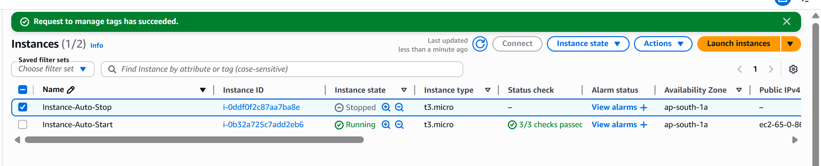
CREATED IAM Role
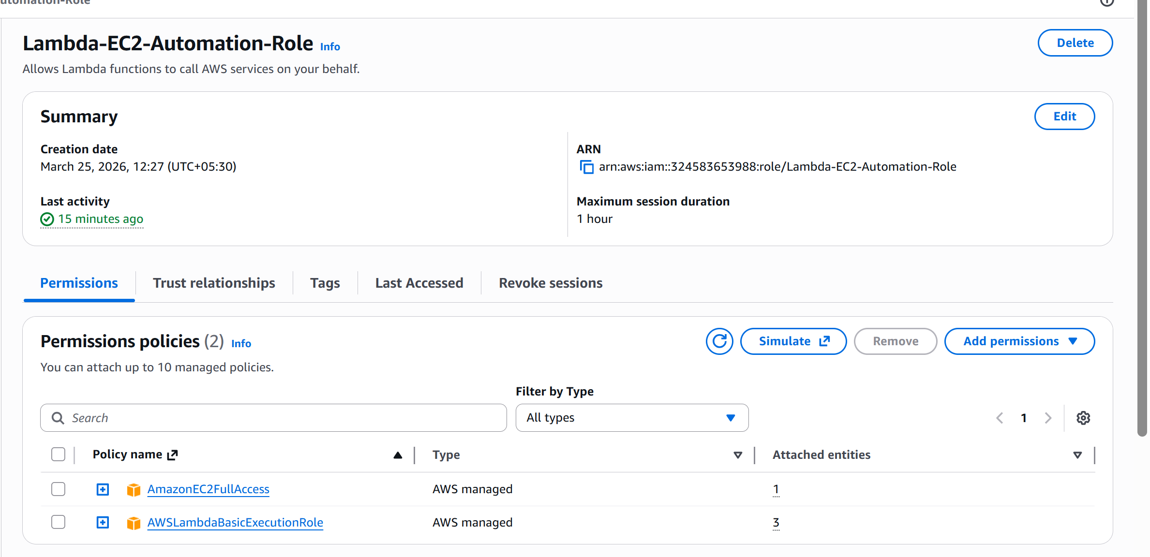

CREATED LAMBDA FUNCTION
- 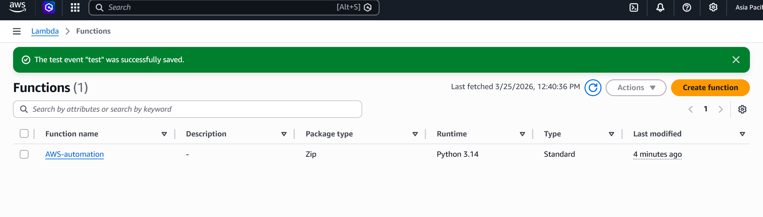
Uploaded BOTO3 Code
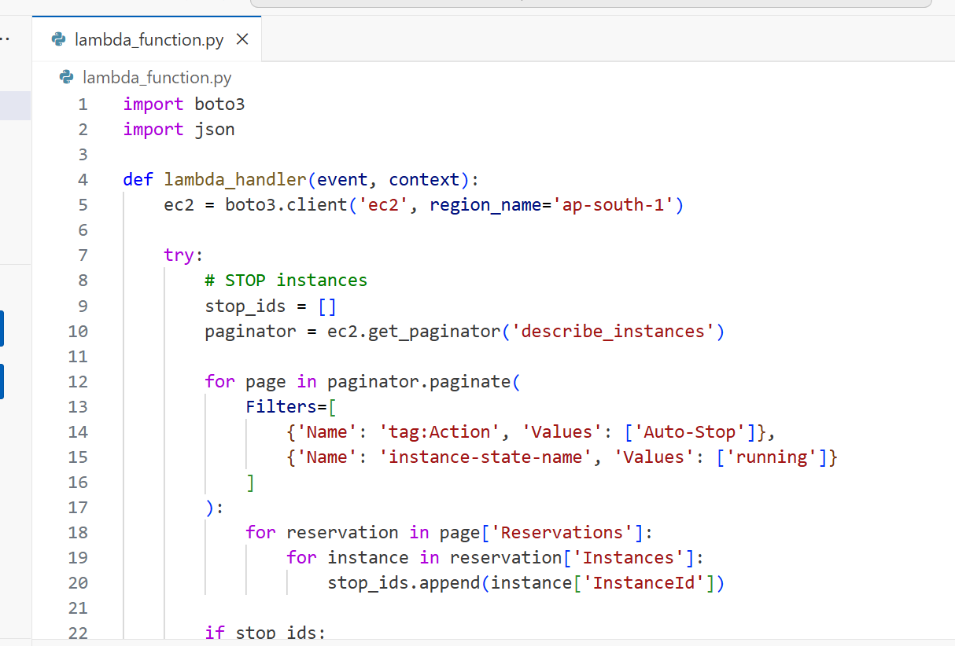
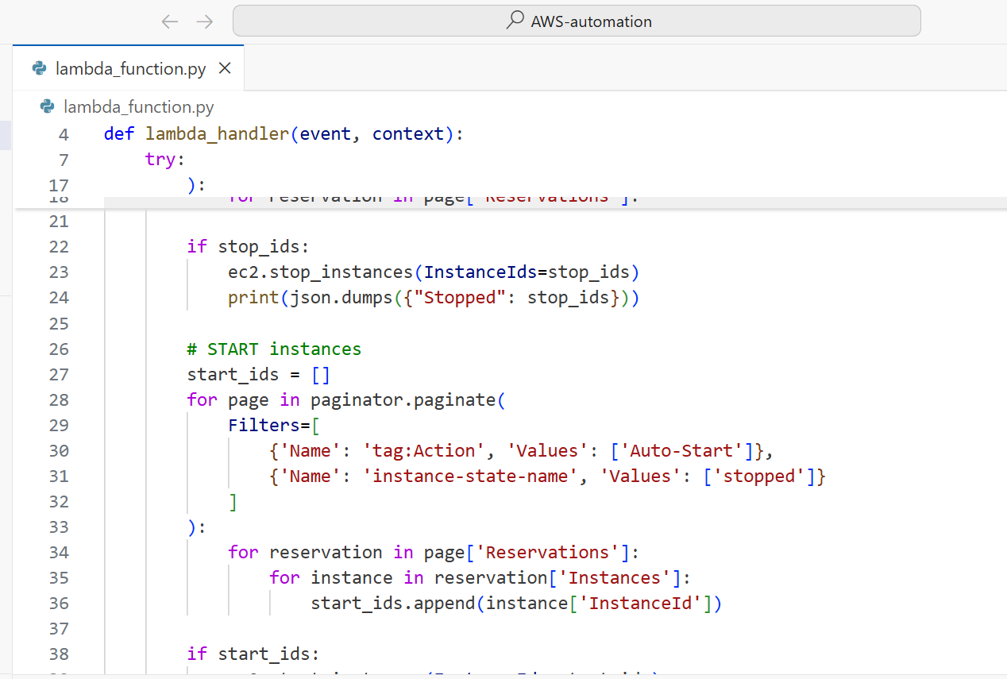
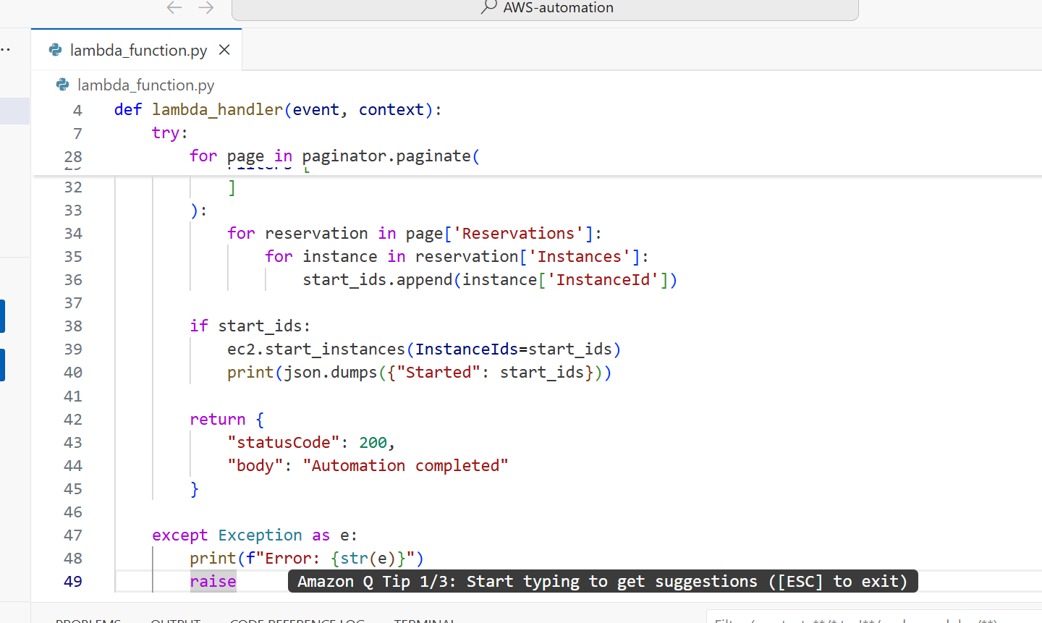

EXPECTED OUTPUT
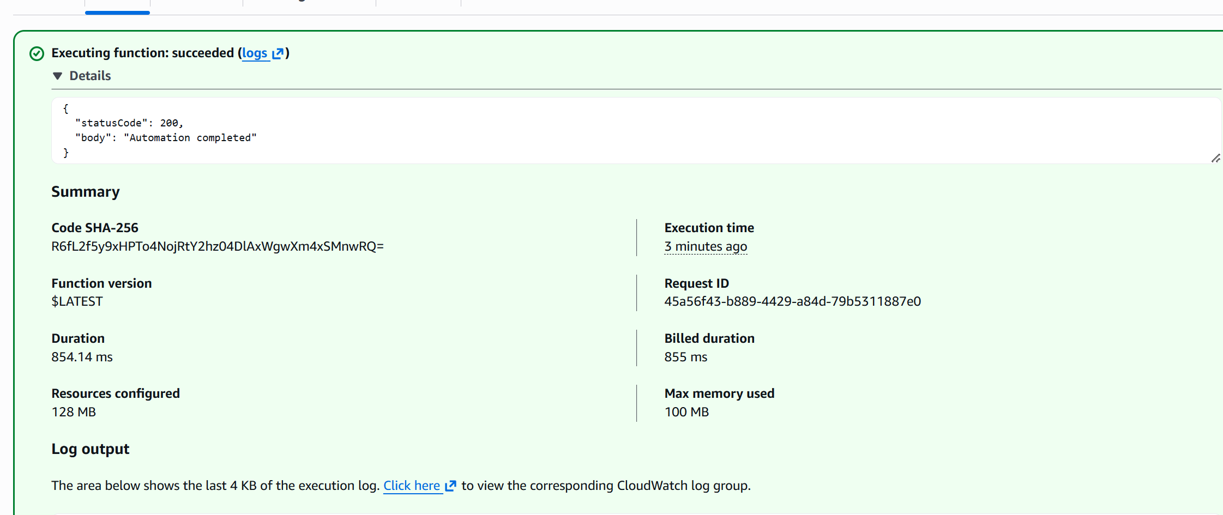
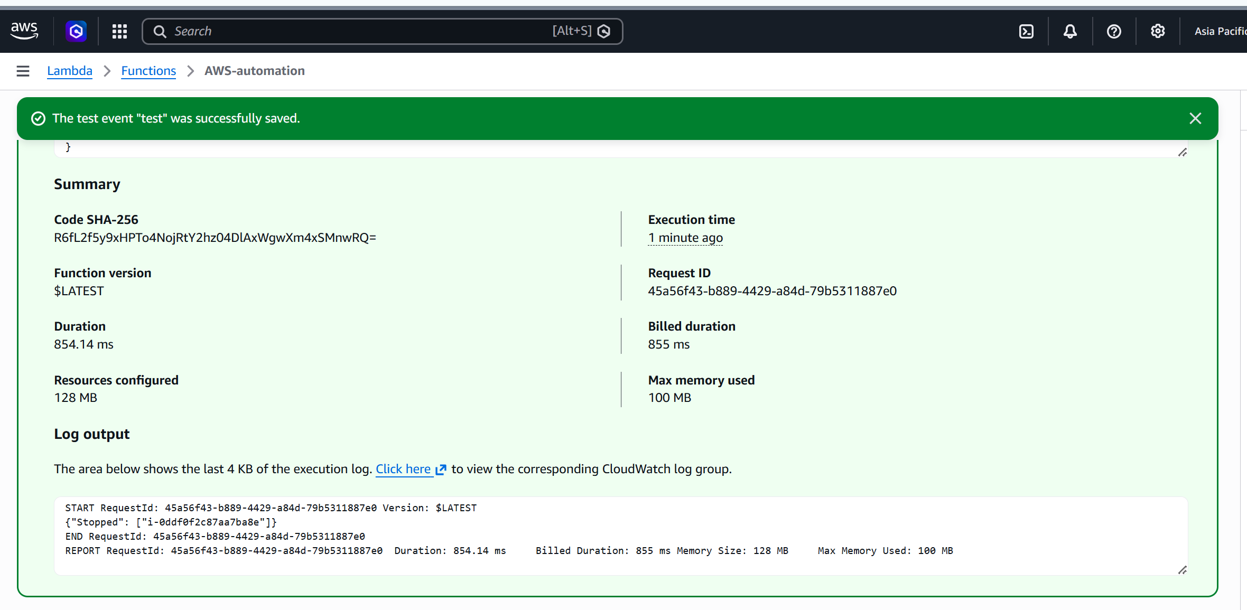


🏁 Final Assignment Status
Requirement | Status
EC2 instances created | ✅
Tags configured | ✅
Lambda created | ✅
IAM role working | ✅
Boto3 logic working | ✅
Instances stopped/started via tags | ✅

